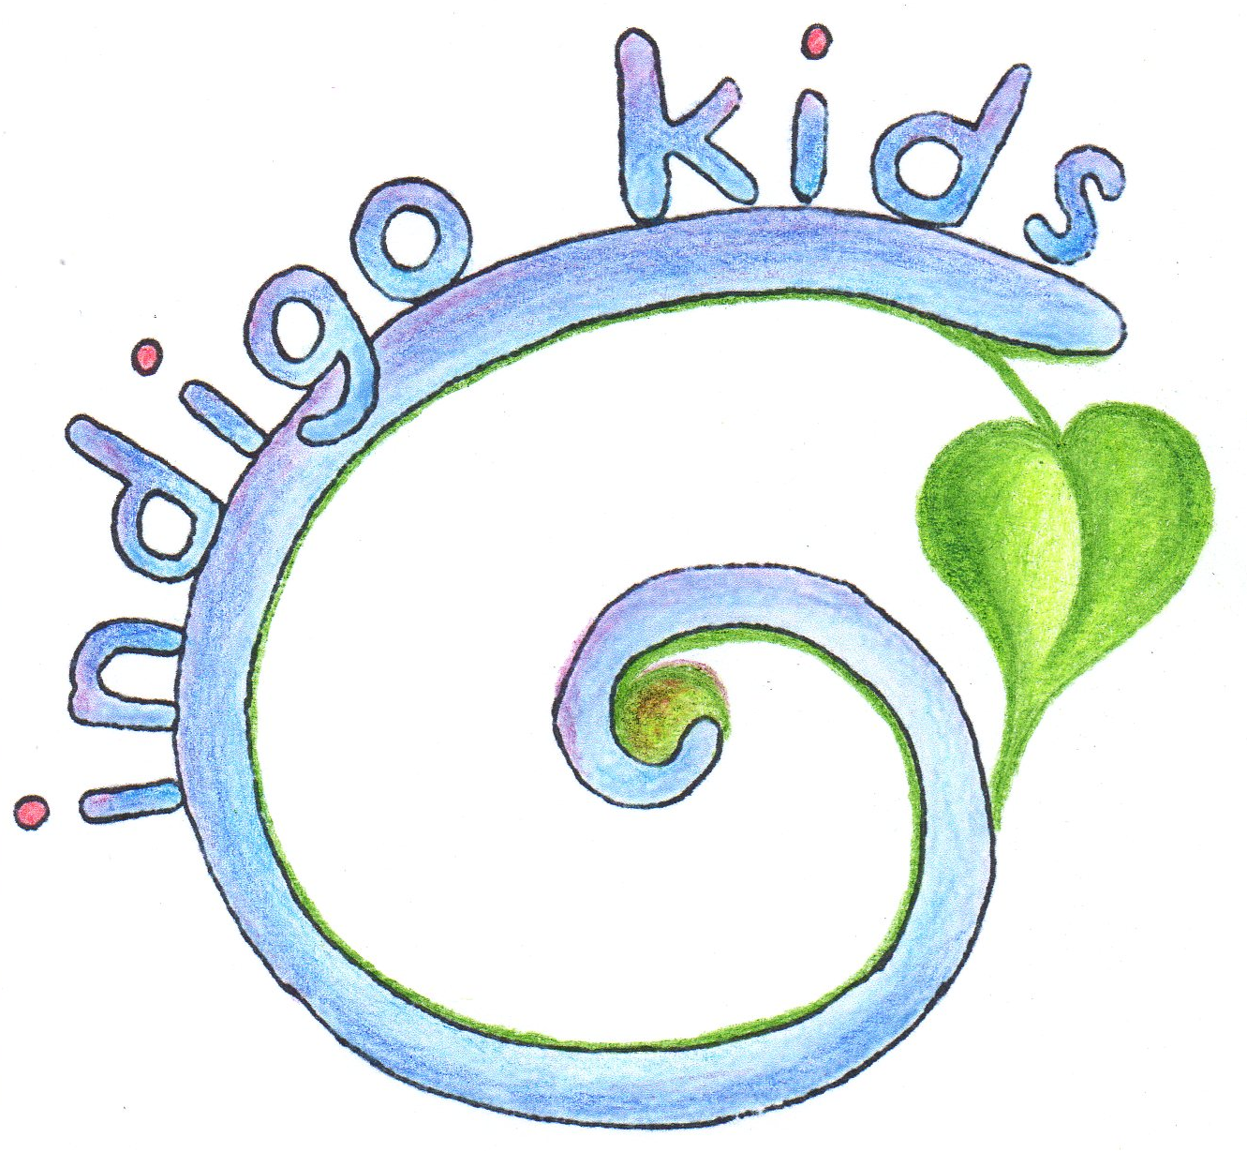

Registration for Children to Indigo Kids Preschool

V Mateřské škole Indigo Kids, v.o.s., Štulcova 69/3, 128 00 Praha 2 – Vyšehrad,
IČ: 02429004

Full Name of Child…………………………………………………………………
Date of Birth: ……………………………….. Identification Number: ………………………………….
Nationality: ……………………………….. Native Language: ……………………………………….
Permanent Address: ……………………………………………………………………………………………..
Insurance Provider.: ………………........................... Place of Birth……………………………………………

Legal Guardians:
Mother Father
Name: ………………………………… Name: ……………………………….
Year of Birth ……………………………………... Year of Birth: …………………………………….
Permanent Address: ………………………….. Permanent Address: ………………………….
Phone: …………………………………………… Phone: …………………………………………...
E-mail: ……………………………………………. E-mail: …………………………………………….
Occupation: ……………………………………. Occupation: …………………………………….

Any additional adult(s) authorized to pick up the child from preschool:

.......................................................................................................................................................

Frequency of Attendance:

Monday  Tuesday  Wednesday  Thursday  Friday 

Half day 8:00 – 13:00  13:00 – 18:00 
Full day 8:00 – 15:00 
Extended 8:00 – 18:00 

Registration for Food Services:

Full day (snack, lunch, snack) 
Half day - morning (snack, lunch) 
- afternoon (snack) 

Dietary restrictions, allergies, and other specifics:

.......................................................................................................................................................

Statement to Parents:

I certify the accuracy of the data provided, and undertake responsibility to notify the preschool administration immediately of any changes thereof.

I accept responsibility to immediately notify preschool administration in the occurance of contact with or contraction of any congagious disease by child or immediate family.

By my signature I affirm that I have read and understood the content of the services provided, as well as the general terms and price of said services.

I acknowledge that the general conditions are an integral part of this application.

I agree that the above data be in the sense of Act No. 101/2000 Coll. as amended and in accordance with Regulation (EU) 2016/679 of the European Parliament and of the Council prepared by MŠ Indigo Kids, v.o.s. This data will not be misused or provided to other persons without my written consent. This consent to the processing of personal data is granted for a period of 5 years from the receipt of the information. I am aware that giving my consent to the processing of the above personal data for the above purposes is voluntary, and at the same time that I may withdraw my consent at any time in writing.

Date.................................. Signature of Parent ........................................................

